Scoresby Primary School

Student Code of Conduct
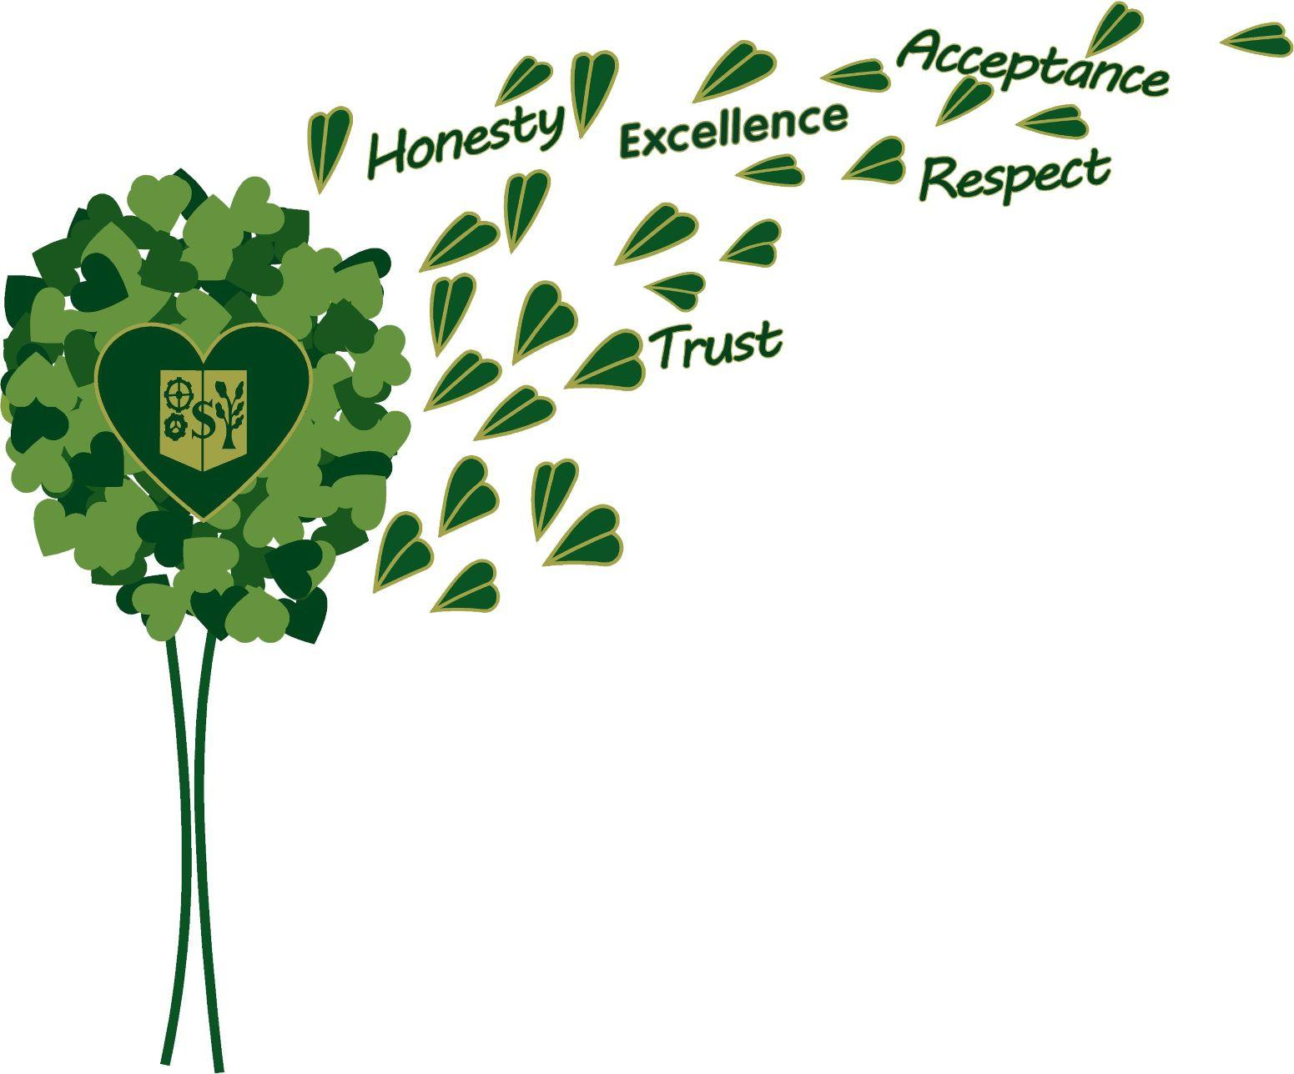
2022

Acknowledgement of Country

We the students of Scoresby Primary School, acknowledge

Australia's Aboriginal and Torres Strait Islander peoples, the

Traditional Custodians of lands, waterways and

skies across Australia.

We thank you for sharing and caring for the land we

learn and play on.

We pay our respects to Elders, and we share our

friendship and kindness.

The Scoresby Primary School Oath

I am proud to be an Australian and a student at Scoresby Primary School.

I aim to work hard, be responsible, and treat children, teachers, and members of our community with respect.

I will do the best that I can.

Scoresby Primary School Song
I’m A Scoresby Super Star

I’m a Scoresby Super Star
Ask me what my values are
I will point to my heart

La di dah, La di dah, La di dah, La la di dah, La di, La la di dah

I am a Scoresby Super Star
What I learn will take me far
La di
La la di da

H
E
A
R
T
(Repeat x 1)

I’m a Scoresby Super Star
Ask me what my values are
I will point to my heart

Dear Student, Parent and/or Guardian,
The best way to ensure that Scoresby Primary School continues to be a happy and successful school is to make sure that all our students feel safe and happy. Every now and again it is a good idea to take the time to think about the really important things in life and realise the crucial role that each of us has in determining the culture at Scoresby Primary School.

As a student at Scoresby Primary School, you have certain rights that need to be upheld - rights that ensure you are seen as an individual and that your side of the story is always heard.

As a very important member of the school community, you also have certain responsibilities. These responsibilities really help make Scoresby Primary School a fantastic school.

Like all organisations Scoresby Primary School also needs to have rules –rules that are fair, understood and followed. As a student at Scoresby Primary School, it is your responsibility to follow these rules –not because you will get into trouble if you don’t but because you understand the importance of these rules in keeping everyone safe and happy.

Please read this booklet very carefully with your parents. Think about the three R’s –Rights, Responsibilities and Rules and help us make each year at school very, very happy and successful for all our community.

When you have read and discussed this booklet with your parents/carers, please sign the attached form and return it to school within the next few days.

Warm Regards

Sue Hartley and Nic Rheumer
Sue Hartley Nic Rheumer
Principal Assistant Principal
Student’s Rights

A right is something which belongs to you and cannot be taken away by anyone. Your classmates and teachers have the same rights. Here are some important rights.

You have a right to:

- Be an individual at school
This means that you should be treated fairly even you are tall or short, regardless of gender, or because of the time it takes for you to solve a problem.

- Be respected and treated with kindness at school
This means that others should treat you with kindness and respect. You should never feel hurt or embarrassed or made to feel uncomfortable

- Express yourself
This means that you may talk freely about your ideas and feelings, at the appropriate time.

- A safe school
This means that your school should provide safe classrooms and equipment as well as rules to ensure your safety at school.

- Tell your side of a story
This means that you may tell your side of the story if an incident arises.

- A comprehensive curriculum
This means that your school should provide programs for you in English, Maths, The Arts, Science, Humanities, Health & PE, Technology and a Language Other Than English (LOTE).

- Support from teachers in dealing with personal matters
This means you have a right to confidentiality if you speak to a teacher.

Student’s Responsibilities

There are some things you should do without being told. Some of these things you do for yourself and some of these you do for others.

You have a responsibility to:

- Come to school:
This means that you come to school every day, on time, unless you have a special reason to be absent.

- Take care of property:
This means that you look after your own things, take care of school property and respect the property of others.

- Obey School Rules:
All the rules are in this book and displayed at school.

- Practice personal cleanliness:
This means you must be clean and practise healthy habits.
- Wear School Uniform:
This means you wear our school uniform to school

- Behave in a quiet, considerate, and courteous manner when at school and on excursions:
This means that you behave in such a way that your teachers and the school can be proud of you as a student.

- Help with your learning:
This means that you work with your teachers and parents by telling them what you need to know and what you’d like to learn.

- Remember safety rules and good manners when using email and internet:
Please refer to our ICT Acceptable Use Policy.

- Take messages home:
This means that you must take all notices and information home to your parents.

- Complete your assignments:
This means that you do your best with your class work and homework and hand them in on time.

School Expectations
Personal
- We don’t allow bullying or discrimination.
- We wear our school uniform with pride.
- We care about our school and its community
- When eating food outside we make sure we’re sitting down either under the shade sail or outside the canteen.
- We look after our school by putting our rubbish in the bins

Attendance
- If we’re late to school, we must be signed in at the office by our parent/guardian.
- We come to school after 8.45 a.m. (but before 9.00 a.m.) unless we’re in O.H.S.C.
- If we’re not collected after school by 3:45 we go to the school office.
- We can enter our rooms at 8.55 when the first bell sounds.

Out in the Yard
- We stay in our school grounds during school hours and only leave with a teacher’s permission.
- We use the paths and keep off the garden areas.
- We keep away from parked cars.
- We stay outside buildings at recess and lunch times and only enter when we have a teacher’s permission.
- Play safely on our playground equipment.
- We make sure that sticks, stones and other hard objects are not used to threaten or make other students feel unsafe.
- We keep out of trees.
- We always play in a safe way.
- Bikes, scooters, skateboards and other wheeled vehicles are to be walked, not ridden on school grounds.
- Helmets should be worn when riding to and from school

Inside the classrooms
- We use the designated entry and exit doors.
- If we’re late to school, we must be signed in at the office by our parent/guardian.
- We go to the toilet in pairs and wait.
- We look after our school by putting our rubbish in the bins
- We leave dangerous or expensive items at home.
- We make sure that swearing doesn’t occur at school.
- We ask a teacher’s permission if we need to get a ball out of bounds.
- Mobile Phones are handed into the office before 9am in a sealed plastic bag

Recognition of Values

The values at Scoresby Primary School will be supported through these processes:

- Praise, reinforcement, and acknowledgement of appropriate behaviour
- Use of House Points
- Handing out of H.E.A.R.T tokens
- Student of the Week Awards
- The knowledge of being a good student and gaining the respect of students and staff

The values at Scoresby Primary School will be recognised in the classroom in the following ways:
- Regularly being addressed through Class Meetings
- Being displayed in the classroom
- Visited (and re visited) through literature

Additional support strategies such as the following may be implemented:

- Monitoring and providing feedback to students on their behaviour.
- Involving parents and care givers to assist with modifying behaviour.

