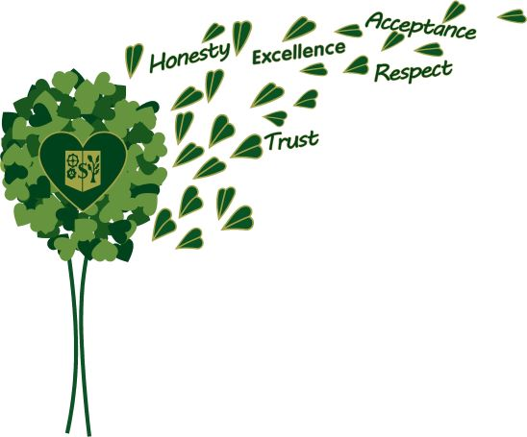
SCORESBY PRIMARY SCHOOL and DET
Enrolment Policy
(internet, social media and digital devices)
Note:
Victorian government schools are not required to have a local enrolment policy as they are required to follow the Department's Enrolment Policy (and any other related Department policies) on the Department's Policy and Advisory Library.

Policy
This policy sets out requirements for entry into Victorian government schools, including admissions, enrolments, the placement of students and transfers between schools.

Details
This Enrolment Policy and the mandatory Enrolment in a Victorian Government School Guidelines, available on the Guidance tab, combines the admissions, enrolment, placement and transfers policies into one clear and concise location for Victorian government schools.
Under the Education and Training Reform Act 2006 (Vic):
- Schooling is compulsory for students aged between 6 and 17 years unless an exemption from attendance has been granted. This applies to all schools including mainstream, specialist, and government English language schools or centres.
- Every Victorian student has a legislated right to enrol at their designated neighbourhood school (section 2.2.13) and may be enrolled at another school subject to sufficient accommodation (section 2.2.14).
Victorian government schools must refer to the Enrolment in a Victorian Government School Guidelines (see Guidance tab), for details on:
- age eligibility, including exceptions and exemptions from the maximum and minimum school age requirements and processes
- determining designated neighbourhood school areas and zones
- Department policy requirements relating to placement of students (Placement Policy) and enrolment management
- enrolment appeal processes and requirements
- determining permanent residence of students and families
- required documentation and information when enrolling students
- transfers between schools
- concurrent enrolment for students entering youth justice or secure welfare.
For policy and guidance on transition process and support for students moving from Year 6 to 7, refer to: Transition — Year 6 to 7.
For policy and guidance on exemptions from attendance and enrolment, refer to: Exemptions to School Attendance and Enrolment.
Review Cycle
This policy will be reviewed every as required by DET. This policy was last updated on the 15th June 2020

SCORESBY PRIMARY SCHOOL
ACCEPTABLE USE AGREEMENT

At Scoresby Primary School, we support the right of all members of the school community to access safe and inclusive learning environments, including digital and online spaces. This form outlines the School’s roles and responsibilities in supporting safe digital learning, as well as the expected behaviours we have of our students when using digital or online spaces.
Safe, responsible and ethical users of digital technologies
When I use digital technologies I communicate respectfully by:
- always thinking and checking that what I write or post is polite and respectful
- being kind to my friends and classmates and thinking about how the things I do or say online might make them feel
- not sending mean or bullying messages or forwarding them to other people
- creating and presenting my own work, and if I copy something from online, letting my audience know by sharing the website link to acknowledge the creator

When I use digital technologies I protect personal information by being aware that my full name, photo, birthday, address and phone number is personal information and is not to be shared online. This means I:
- protect my friends’ information in the same way
- protect my passwords and don’t share them with anyone except my parents and teachers
- only ever join spaces with my parent’s or teacher’s guidance and permission
- never answer questions online that ask for my personal information

When I use digital technologies I respect myself and others by thinking about what I share online. This means I:
- stop to think about what I post or share online
- use spaces or sites that are appropriate, and if I am not sure I ask a trusted adult for help
- protect my friends’ full names, birthdays, school names, addresses and phone numbers because this is their personal information
- speak to a trusted adult if I see something that makes me feel upset or uncomfortable, or if I need help
- speak to a trusted adult if someone is unkind to me or if I know someone else is upset or scared
- don’t deliberately search for something rude or violent
- turn off or close the screen if I see something I don’t like and tell a trusted adult
- am careful with the equipment I use

At school we/I have:
- discussed ways to be a safe, responsible and ethical user of digital technologies
- presented my ideas around the ways that I can be a smart, safe, responsible and ethical user of digital technologies
I will use this knowledge at school and everywhere I use digital technologies.
SCORESBY PRIMARY SCHOOL
ACCEPTABLE USE AGREEMENT

This Acceptable ICT Use Agreement applies to all digital technologies and the internet including (although not limited to):
- school owned ICT devices e.g. desktops, laptops, iPads, televisions, printers, scanners
- mobile phones and student owned devices
- email and instant messaging
- internet
- social networking sites
- video and photo sharing websites e.g. YouTube
- blogs, micro-blogs and wikis e.g. Twitter, Wikispaces, Wikipedia
- forums, discussion boards and groups e.g. Google groups
- vod and podcasts
- video conferences and web conferences

This Acceptable Use Agreement applies when digital technologies and the internet are being used at school, during school excursions, camps and extra-curricular activities.

This agreement is in line with the Scoresby Primary School Digital Technologies and Media Arts policy, which is available on our school’s website: http://www.scoresbyps.vic.edu.au/

In the event that a student inappropriately uses any ICT hardware or software at school, consequences will be put in place. For example:
- Parents and member of principal class to be informed
- Student to use digital device with a responsible classmate for a period of time
- A meeting between the student, teacher, family and member of the principal class
- Serious breaches may result in a temporary loss of school access to ICT equipment as determined by the principal

As a student I continue to learn to use digital technologies safely and responsibly.
I will ask a trusted adult for help whenever I am unsure or feel unsafe.

Student’s Name: _______________________________ Grade: __________ Date: _____________

Student’s Signature: ______________________________________________________________

I understand that my child is expected to comply with the terms and expected standards of behaviour
as set out within this Acceptable Use Agreement.
Parent / Guardian Name: ___________________________________________________________

Parent / Guardian Signature: ______________________________________________________

